Planning for your first 100 days and Maturity Overview

Week 3
  - Summer School 2023
©2023 Carruthers and Jackson Ltd.

The First 100 Days

The critical tasks of the first 100 days are making the ‘case for change’; assessing the level of data maturity; defining the destination and the scope; and establishing the data basics.

How would you climb Mount Everest? One step at a time! It can seem like a completely overwhelming task at times, but by focusing on the next step, you will be looking back at the end of the first 100 days and how much you have achieved before you can even count to 100.

When you take on the role of a Data Leader, you can expect to spend a lot of money on tea, coffee, cakes and biscuits! A large part of this role is based on relationship building, finding data cheerleaders, and securing senior sponsorship. So, get ready to spend a lot of time meeting people; hence the drinks and treats budget!

Much of what determines success or failure going forward will take place in the first 100 days. Essentially, it is getting the basics right at the start, to be able to build firm foundations for the future. For ease, we will be referring to the role as ‘CDO’ instead of ‘Data Leader’ from here on in.

What can you expect when you start?

The first 100 days are important to set the expectations for the CDO you are going to be.
Now, from one (two) Data Leader(s) to another, expect a real rollercoaster of a ride: there will be amazing highs, followed by moments where you sit with your head in your hands wondering why on earth you chose the role. This is somewhat of a microcosm of your role as a CDO, in a short period of time.

Prep work

There is a bit of prep work that you need to do before you really get stuck in. This is considered the ‘pre-basics’ and you must spend a good amount of time on this.
You need to understand the business. Whilst this goes without saying, we are quite pedantic and so we will talk about it anyway!
There are only two ways into the role of CDO: from inside the company or from outside. Neither is an excuse for not doing your prep work and not understanding the business properly.
So, start by listening, listening and listening. And when you think you are done with that, listen some more. Don’t ask questions about data – as we have said before, data is considered a bit of a four-letter word for most people in the business. We might care about the difference between data and information, or the value in well-placed metadata, but that is probably not how the rest of the business sees the word.
Ask your peers, and anyone else in the organisation, to take the time and spend it with you over a drink to share what problems they are facing; what keeps them awake at night; and what they are really proud of. Remember, don’t ask questions about data. Use language that they use and ask a lot of open questions that lets them share their priorities.
People will naturally gravitate towards talking about the data and information and problems they are having because they are (of course) aware of what your title is, but you can find some real gems in the areas they don’t even realise are data related. You will be truly amazed by how many big organisation-wide problems are actually related to data, somewhere near the root cause. People, no matter how senior, will happily talk to you about the ‘shopping list of things’ that need to be done to help them.
There are two other areas that you need to be aware of whilst you are investing your hard-earned money in tea, coffee, biscuits and cake.
The first area is politics. Every organisation has politics in some shape or form. You might not need to take part, but you definitely need to understand it. Understanding the politics helps you avoid any verbal landmines and could also lead you to some important sponsors/stakeholders in the business that are worth getting to know.
The second area is the importance filter. You will need to master the skill of filtering the information that you are getting. Is this something really on fire, or is it just smouldering while the city is burning behind it? Is it someone’s pet hate or bug bear and fixing it could have a much larger gain in credibility? How strategic is it - will it take a long time to fix, or can it be a quick win? These are also things that will need to be factored into your planning.

Ah, yes – we used the “planning” word. We are not suggesting that you come up with a 1000-line Gantt chart (however if that floats your boat, then carry on) but let’s not pretend that you can complete a journey without a map of some description. The first plan will probably not be pretty, and it will change, but it will give you the next step to take when you have lost your way.
While you are meeting with all these stakeholders, find out what the heartbeat of the organisation is; what pattern there is to meetings; what crucial meetings you need to be a part of and make sure that you stay plugged into. Basically, what makes the organisation run?
Finally, make sure you understand the procurement and finance processes. You will be spending time using both.
We know that this probably sounds like a great deal of pre-basics, but they are all really important!

The case for change

So, now you have covered your pre-basics, the very first thing you need to start doing in your new role, is to understand your organisation’s need for change. If it is not there, create it. If there is one and it needs help, redefine it. But whatever you do, make sure you have a clear, easy-to-describe case for change.
To be an effective CDO you will be changing the organisation, and no change starts better than with a burning platform or a massive benefit delivered quickly. If you do not establish the case for change, then you might as well go home at this point. Without the case for change, you are doomed for poor results or outright failure.
The case for change helps you set the vision of your deliverables: what benefits you are aiming for; whether the benefits are saving the organisation from repeating mistakes or gaining insight to derive more value. It is the compelling argument that makes people want to help create the future you are selling.
The case for change also helps to set your scope and start to set expectations about what you will and will not be doing. People often forget about the “not doing” part of a scope, but it is equally important, if not more so, as the “doing”. If the expectations are not set, people can overlay their own expectations and just assume that they are getting everything they have ever wanted, just because they have misinterpreted what you meant. Whilst you need to create a compelling vision, it is best to be realistic about where you can go, what it will feel like, and how long it is going to take to make a difference.

Vision and strategy
While the compelling case for change tends to focus on the downside of life – unless you are a disruptor and have a genius idea to leapfrog the business forward – the balance comes in the form of your vision and strategy.
At this early stage you should be able to come up with a good strategy that is high-level and visionary. There are so many different variations of a good vision but something memorable, concise, and meaningful to your business is what you should be aiming for. Data Strategy will be covered in more detail later in the course.

Information basics
There are three areas that you need to progress in the first 100 days, and these are listed below. In 100 days, you will not get them finished but they are where you should start.
- Governance: What is the basic governance structure you need in place? Get agreement on the structure. Who is responsible for what and how can you tie this together? What are you aiming for?
- Information architecture: How does information flow through your organisation? Where does the data come from, what happens to it on its journey and where does it go? Also, who is accountable for the data at each state of its journey?
- Engagement: you must win the ‘hearts and minds’ battle if you are to succeed. Take every opportunity to engage with people, to sell your message, and to convert people into data cheerleaders.

Quick wins
The next thing you have to do is get some value from all of this, quickly. 100 days will pass by in the blink of an eye for you, but the business has invested in you and will want to see some return on their investment.
You need to find something that demonstrates the value that you can get from the data, early on. You have the vision, the people, and an idea of the information architecture – put them to use to find some quick wins, to show the organisation why it is worth working with you.

The next 300 days
So, you have got through the first 100 days, settled into a new business, met your new colleagues, got a first impression of the data environment and the state of the nation. You have also carried out your own assessment of the maturity of the data environment. You are probably bursting with ideas and plans. In our experience, you will have spoken to more people than you can remember and have been in a lifetime of meetings. That is the only way to throw your arms around what is going on and to make a true assessment of the data estate and processes.
While things will obviously look different depending on what generation of Chief Data Officer you are, the steps that you take are the same. A Second Generation Chief Data Officer might be able to skip through some of the steps faster, as there will be more information readily available at their fingertips, but if you miss the steps altogether, how confident are you that you are standing on firm foundations?

The Next Three Steps
This is the moment to do three things, and they are sequential.
First:
Draw a breath and take a moment to pull all the thoughts and the meetings together. Review the notes you have taken and make an assessment on the state of the data maturity and what needs to be done.
Second:
Create a story around this – have the details and examples and play the current situation back to your stakeholders. However dire you may think the current situation is, the business has been operating and working with data and so there will be positives that you can play back. Make sure that you don’t go around proclaiming that the “sky is falling” but do let them know where the real problems lie.

Third:
Draw back from the business slightly; it is time to think and plan. The start of the 300 days is the time to build your data team around you, either by external recruitment or internal moves. It is time to identify your SWAT team -your transformation team - to start work on your minimum viable products and to decide on the shape of your final data organisational design.
You will need support to get through the next 300 days.

Tasks to be Achieved

There are two high-level tasks that should be achieved in the next 300 days:
- Deliver the Immediate Data Strategy, the tactical fixes, and have one eye on the hype cycle. What the tactical fixes are will largely depend on the outcomes of the 100-day assessment and the context.
- Write the Target Data Strategy and have it in the blocks ready to start the transformation, and ready to deliver.

Achieving these two together can be tough, hence the need to gather your data team around you.
One of the biggest traps that you will be tempted into in the first year, is to get down and dirty with the detail. There will be lots of things to work with and your job is to understand the coverage, not the detail. Try and keep the detail at arm’s length.
Trust your team and keep your focus on making the path easier for them. It is therefore essential to have the ability to recruit good people with the right skills and experience, and then trust and empower them to deliver.

Data Maturity Model Assessment

Understanding the elements of the data maturity model

A maturity assessment is an incredibly useful tool in your Chief Data Officer tool bag, hence why we have devoted two weeks of the CDO Summer School to this topic.
The maturity assessment is critical to the understanding of the overall state of the organisation before you start, or from where you get a chance to start the process. The assessment will also be useful when you are demonstrating progress as you will use it as the baseline in your ongoing assessments.
Lots of changes fail because the time was not taken to understand the true position of the organisation. Moving your organisation to be more data enabled will mean you are making changes to it.
We are not suggesting that you can know everything in advance, as it is blatantly obvious you can’t! We are, however, suggesting that if you take a little time to understand where your organisation stands on the important factors in relation to how it treats data, then it vastly increases the chances of you being successful. The whole point of this is to make sure you understand where you are so that everything you are planning can be built on solid foundations, it is the start of your data treasure map – without the start, you will never get to the end.
We have worked on projects where major failures took place because of simple misunderstandings between two people who believed they were talking about the same thing; in fact, they were miles apart, because they had not taken the time to check that their basic understanding was the same. Don’t be afraid to check the basics; different people use the same terms to mean different things. Remember the only stupid questions are the ones you don’t ask!
The Maturity Model we use is based on a holistic view of the organisation, rather than limiting itself to just one area such as technology. It helps organisations understand that there are many ways to become more data mature, and which business areas have a strong part to play.

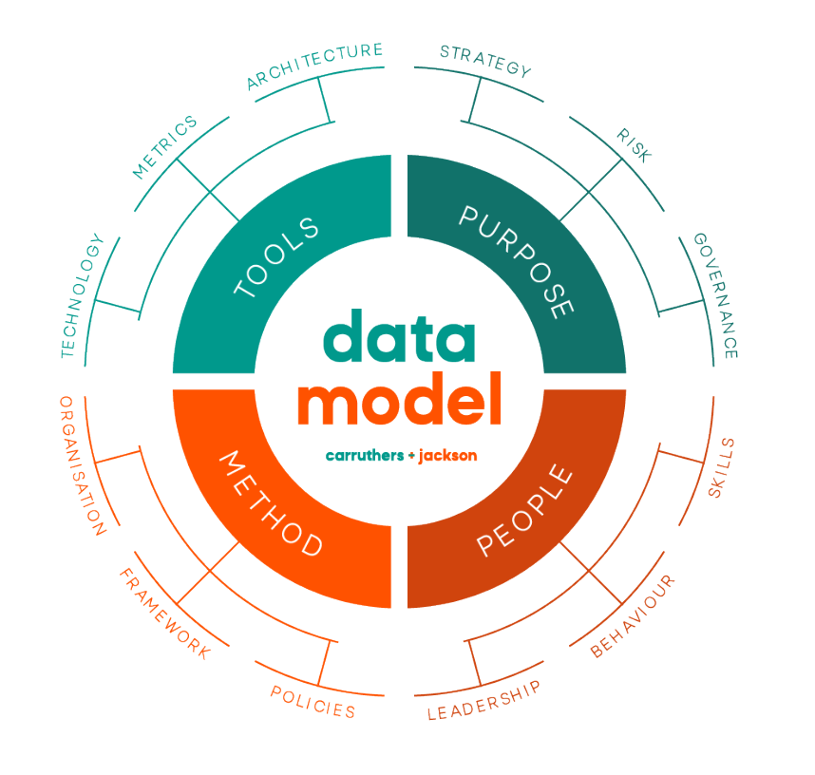

The model is divided into four quadrants, each consisting of three elements.

Purpose – Everything starts with purpose, otherwise why are you doing it? Data should underpin the business strategy, and this is the area that makes sure you do. Pay close attention to this area as it is a fundamental part of your data journey.
People – People are a major component of any model when it comes to change, and data is no exception. We have said it before and we will say it again, it is so much more powerful when your whole workforce understands what a great asset your data is and they have all the right tools for success, rather than just a few specialists sitting in an ivory tower.
Method – This part of the model is concerned with how something is put in place to help the organisation be successful. Basically, this covers; the rules, the referee and the team when it comes to playing the data game.
Tools – This is all about the tools you need to not only play the data game, but play it well.
The other important aspect of the Data Maturity Assessment Model is where you would mark yourself against it. The scale is:
0 – Unaware: We know that there would not normally be a 0, but it would be
naïve to not realise that some organisations aren’t aware that they have to think about something. Yep, we have all been there: the old unknown unknowns! Where spreadsheets are everywhere and Excel rules. Everyone is taking data from everywhere and modifying it without any thought to what other people need it for. This is the equivalent of the Data Wild West.
1 – Aware: There are a few processes in place, other than those required by legal demands and industry regulations, and whilst ad hoc efforts are made, there are very low levels of trust.
2 – Reactive: Some processes are emerging, yet they are not monitored and are regularly worked around. Data quality checks are done in an ad hoc fashion. The idea of standards is just starting to emerge, but normally in response to an issue faced or direct data breach.
3 – Proactive: Processes are developed by information/data stewards who have limited authority. A Master Data Management programme has started, the governance of unstructured data has started to emerge. The organisation is starting to get ahead of the curve, but there still seems to be a long way to go.
4 – Managed: Information governance is in place; there is a data function at the enterprise level, stewards and champions are working together, and things are evolving into a proper framework which is communicated and assured.
5 – Optimised: Nearly all the information assets are inventoried, including knowledge of the external sources. Information is advocated across the business. There is enablement and value generation; It is transformative. Data is used internally and externally to make sure the organisation is “cooking on gas”. True partnerships between the customer and supplier are embedded. The data landscape is trusted and agile.
As this is likely the first time that the Maturity Assessment is being carried out, it will be time intensive. It will be intensive for everyone involved in the organisation and so everyone should know that it is coming. Half-day workshops and 2-hour long interviews suddenly appearing in someone’s diary is not going to win friends. It is important that there is a spread of people from across the organisation. At minimum there should be representatives from every department across the organisation with heavier representation from HR, IT, Finance and any other heavy data usage areas.
The more people that can be included, the more unbiased the outcomes will be, in turn adding richness to the results achieved from the maturity model. Another good reason for doing this assessment is that it provides a chance to start the education process on the goals and objectives; what is going to be achieved. We can guarantee that people will try and cut these meetings short, but do not let the meetings be rushed through. There needs to be a great story for why their time is needed and what they will get out of it, both in the short term and long term.
The first exercise, information gathering, should be conducted with face-to-face discussions, because of the multiple reasons that the Maturity Assessment is being carried out. From stakeholder management to fact finding, these are valuable. There should be formal questions and a section where the respondents can talk about what is on their minds, which will become brilliant fact finding for later on in the process: what keeps them awake at night; what do they think are the opportunities?
For the key stakeholders, a one-to-one session is best, which gives the time and attention to ‘convince’ them to be a cheerleader for this initiative going forward.
This part should not be about data in any way; language should be used which makes the respondent feel comfortable. There should be enough time spent going through each of the questions, ensuring that there is common understanding and one interpretation of what is being asked. It is okay to course correct as the assessment goes on – it is easier to fix things at the start than the day before the deliverables are due.
To get the best coverage, use a workshop to bring groups of people together. The group should consist of people either from the same area or with the same focus, as they will generate ideas from each other and get a richness that may be missed if there is just one representative from an area.
For the workshop, it is important to work with a good facilitator. If you are a good facilitator, then excellent, however if you have more than five people in the workshop, then take someone else in with you. Having someone else in the workshop helps manage the dynamics in the room whilst giving you space to concentrate on what is being said.
Whichever format is being used – one-to-one session or a workshop – the process should be the same:
- Explain what is being done
- Explain why it is being done
- Allow for a short but limited time to air concerns
- Explain what is in it for them
- Explain what is in it for the rest of the organisation
- Show a strawman of what is trying to be achieved
- Go through specific questions based on the criteria listed above, making sure you have a few questions for each area – just one or two questions and you will get skewed results. Try for a consensus score in a workshop, but make a note if this is impossible
- Have an ‘open time’ so that participants can say what is on their minds

Evidence should be gathered from each interview and/or workshop. As some areas are subjective, it will not be possible to gather tangible evidence, however the more that can be gathered, the stronger the arguments will be going forward.
It is hard to argue with cold data, but it is also very hard to argue with a compelling story.
Whilst it is easy to say that you should mark yourself as a ‘5’ on the Data Maturity Model Assessment, it is also a bit unrealistic. It is also highly unlikely that the changes that need to be made, to make your organisation exemplar and keep your stakeholders happy, will be made within a short enough period of time.
Therefore, it is important that the time is taken along with key stakeholders to determine:
Where are the priorities within the data maturity assessment model? Which areas will make the most difference to the business? Which areas are okay with being ‘good enough’ for now? Remember that this can be changed, but it helps to focus people’s minds on the direction that is being taken for the business.
Since we aren’t fans of wasted effort, it is worth mentioning that this baseline Maturity Assessment will also be used as part of the governance and assurance activities later on in the program. Any throw away spend needs to be kept to a minimum! However, when you do repeat the exercise, it will not be as intensive or time consuming as this first time.
Having the Data Maturity Assessment Model as an annual exercise is a great idea, because you can use the spider diagram to demonstrate your progress. However, if you try and repeat the exercise exactly as it is and use all the same people’s time as the first round, there may be a rebellion.
With this pass through, for those that have completed the first round, it may be easier to have them complete the assessment themselves, either as an in-department workshop or as a questionnaire; It depends on the level that is required. Using a blend of different methods will give flexibility to engage with a good breadth across the business, without quite such an overhead.
For anyone that has not been a part of the Data Maturity Assessment, we would still recommend the time being spent with them to understand the wonderful world of data.

Homework
- What do you think will be (or were) the biggest challenges in your first 100 days?
- How do you think your strengths will get you through?
- How will you tackle the next 300?
- Think about who you would include in your maturity workshops, which roles are going to give you a breadth across your organisation? Which are the key roles that you must have?

- Which is the most important quadrant and why?

Program Content

This is the content for the 10-week program:

Program Content

This is the content for the 10-week program:

Week 1- June 29th
Understanding the different types of CDO and what kind you are

Week 2 – July 6th
Making the Case for the CDO & business case development. Telling Your Data Story With the 3Vs:
Vocabulary, Voice and Vision

Week 3 – July 13th
Planning for your First 100 Days and Beyond & The C&J Data Maturity Assessment overview.

Week 4 – July 20st
Strategy development: Purpose

Week 5 – July 27th
Strategy development: Risk and Governance

Week 6 – August 3rd
The role of People

Week 7 – August 10th
Methodology

Week 8 – August 17th
Tools

Week 9 – August 24th
Building your team & Authentic Leadership

Week 10 – August 31st
The Chief Data Officer as a disrupter & wrap up of the Summer School 2023

The Summer School Community

As a participant of Summer School, you have joined a community of current and aspiring CDOs, where you will gain practical advice, proven methodologies and guidance to put back into the business straight away. Your homework as you progress through the course will build a series of artifacts for you to use in your organisations.
Exclusive Community Groups

Within the Carruthers and Jackson website, there is an area just for you. The ‘Exclusive Content’ section is solely for the participants of the Summer School.
The group will be used to share pre-class work, classroom materials, and homework. You will also be able to catch up on all sessions missed.

We have also created a Slack group and a LinkedIn Group. These groups will provide an environment to network and interact with peers. Please check the groups regularly for updates and information or drop in to say hi to your fellow students.

You can access the Community Page & Groups here:

Website:
https://carruthersandjackson.com/exclusive-summer-school-content/

Slack:
https://join.slack.com/t/carruthersjac-w3l8573/shared_invite/zt-1wdo67jdg-KuR8qZdxQOe1hLYabFPGRw

LinkedIn:
https://www.linkedin.com/groups/12845246/

These groups are reserved for the sole use of the Summer School, the school leaders, and participants. Please ensure you remain respectful to other group members, at all times. Any posts that are commercial or deemed unsuitable by the group managers will be removed.

