Making the Case for the CDO

Week 2

  - Summer School 2023
©2022 Carruthers and Jackson Ltd.

Have you come across any of the following scenarios in your organisation?

 Your CEO wants to run a data-driven organisation by: getting better engagement with customers; reducing customer churn by understanding and predicting their needs better; or increasing business efficiency; or perhaps your CEO just wants a better corporate dashboard to help with decision-making.  Your lovely financial system is perceived to be flexible and easy to use. It allows users to search on different criteria. However, it is discovered that when a query is run on an employee’s expenses, there are widely different results depending on which analyst integrates the system. The ‘eureka’ moment is when it is realised that the employee is known by their middle name but filed on the system by their first name. So, while ‘Frank Smith’ has never claimed any expenses, ‘Henry Frank Smith’ has not been following company policy.  Data is stuck in silos within business units or departments across the organisation, and there is no way to effectively share data.  Data issues are resolved at the end of a project, because data cleansing and data migration are only an afterthought. In addition, spreadsheets were used instead of proper ETL (Extraction, Transformation and Load) tools. This ‘after-project’ cleansing data consumes a lot of resource and time, and has considerable impact on the business.  After completing a long and complex project, a ‘lessons learned’ exercise is completed. This exposes the pain of mistakes that have cost time and effort to ensure they are not repeated, and includes the parts of the project that went well to ensure improvement. The report is filed and stored. A year later the same mistakes are realised in a similar project, as the ‘lessons learned’ report was not used by the business as it could not be found. The lessons were not learned, they were filed. | It has been decided that a shiny new IT system is worth the investment to be able to share data and information in a more collaborative fashion. It is important that none of the really good data that is in the legacy systems is lost, even though it cannot be found. The organisation is sure that it is the system that is old and creaking. The Total Cost of Ownership is approved, however when the cost to move all the data from the old system to new is calculated, it amounts to more than the shiny new IT system will cost to implement and run.  The data analysts or teams preparing reports, are spending most of their time sorting out data issues rather than analysing or reporting.  There is the world’s most intricate spreadsheet, truly a thing of wonder with thousands of lines in it. If data is entered in very specific places, a user will nearly get what they need and want. If the data entry is not quite right but close enough, with a little manual manipulation the user will get what they need and want. It is not possible for the user to make any changes to the spreadsheet, as they do not understand it. The creator of the spreadsheet left a long time ago and documentation was not part of the remit. Or perhaps the spreadsheet has started to fall over and stop working, as more and more data is entered. Or it could be that the spreadsheet version is no longer supported. Or it could be that everyone has started using their own spreadsheet with no version control.  Applications in the IT stack need replacing, yet nobody has any idea of the data lineage between applications, or the upstream or downstream impact of replacing a single application.

If you have ticked at least one box and any of this sounds familiar, then you are not alone. These scenarios happen across all large complex organisations which have not placed enough emphasis on the management of their data and information.
There is no single, big, easy reason to convince an organisation to take data seriously, but there are a million small ones that are happening every day. These are the real reasons that there should be a data leader.
A CDO gives cross-organisation vision and strategy for data, potentially for the first time. Does this sound like a culture change? You are right. In some areas ‘culture change’ can be considered a dirty word, but anything that gets an organisation thinking differently, is a culture change.
One person on their own will not be able to deliver the change needed to get the best from their organisation’s data. A team of people, whether small or large, will feel as if they are climbing Mount Everest as they try to get every single person in an organisation understanding why data is important, and treating it accordingly. Only when the organisation works together with the CDO and their team, is there a task that begins to look a lot easier.

The hype cycle relating to the CDO journey

Trigger of Data Awareness
At some point the organisation becomes aware that it needs a CDO (or a senior data leader), to be responsible and accountable for the organisation’s data and for driving value from it. We identify several things that may cause this trigger; Regulatory pressures; commercial pressures and opportunities; operational pressures and opportunities; the potential for customer delight, and simply because everyone else is getting one! At this point, the organisation decides to recruit a CDO.

Peak of Expectations
We have already discussed that almost as soon as the Trigger of Data Awareness has been pulled, expectations will begin to mount.

Table of Enlightenment
We now realise that the CDO needs to harness these expectations and use them to their advantage. Take the senior stakeholders and the business on a journey of enlightenment, educate them, but do this without squashing or deflating their expectations. Use their expectations to secure budget and set an agenda and strategy. The education process and raising the data literacy, will bring the stakeholder to the edge of the Table of Enlightenment.

Cliff of Reality
If the data education and improvement in data literacy has been successful, perhaps supported by a Data Maturity Assessment, your stakeholders will descend the Cliff of Reality, they will reset their own expectations and the organisation’s expectations. They will realise the tasks, challenges, and the journey that is faced by the whole organisation, and not just the CDO, to become Data Mature.

Acceleration of Delivery & Value
At the foot of the Cliff of Reality, the Acceleration of Delivery & Value can begin.

Managing the Hype Cycle with the DIKW Pyramid

Data, Information, Knowledge, Wisdom

The DIKW pyramid is a useful tool to understand and communicate your approach, managing through the Hype Cycle.

It is accepted that wisdom is built on knowledge; knowledge is underpinned by information; and data is the building block of information.
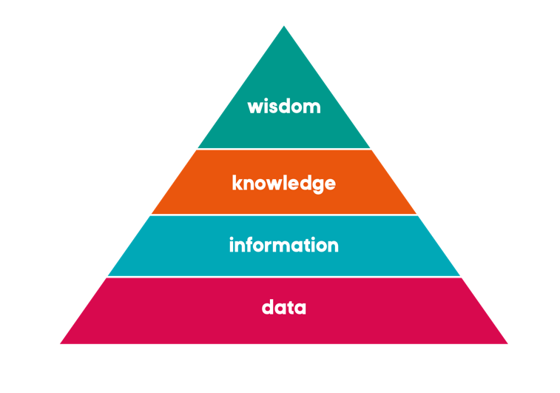

We’ve updated this slightly to reframe what we mean by information in this context. So, what we are talking about is collated, contextualised, and curated data.
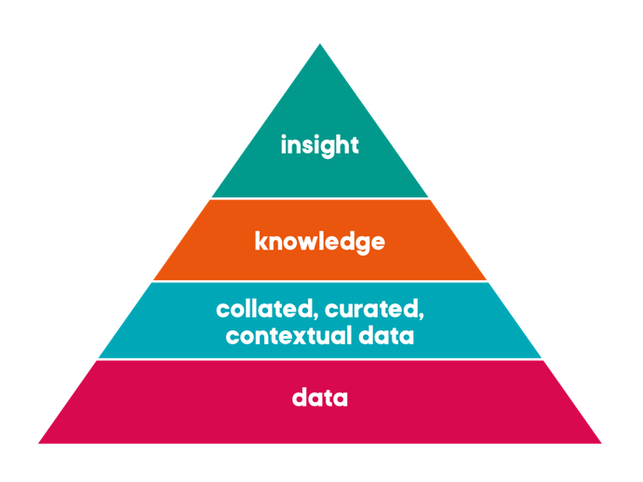

Image source: https://blog.coveo.com/data-normalization/

Whilst common sense, and the CDO, will tell the story that the strategic approach starts with getting the data foundations firm and stable, this diagram can be interpreted to suggest that this is a linear process.

We all know that data is anything but linear: you will not resolve all your data challenges, to then tackle information, and then knowledge, before arriving at wisdom. There will be various iterations moving around within the DIKW pyramid.

If you hold off on delivering almost immediate value, or fail to tackle the burning platforms because you are concentrating on fixing the foundations, you can understand why disillusion will set in with the CEO, colleagues and the Board, no matter how much you tell them about the strategic approach.

The best approach to avoid disillusion, or tackle the burning platforms that may be putting the business at risk, is to strike vertically up the DIKW pyramid. You first need to find the ‘data opportunity’ or an area that can (and needs to be), fixed fast.

Find the opportunity, fix the data layer that underpins it as best as you can (be careful with the perfection ‘disease’), use the right tooling available, and bring this data together to create assured and valued information for the business. Then, go and have the conversation with the business about the knowledge and wisdom that can be derived, to create real business advantage.

This tactical vertical strike, as part of the pyramid, will add to the whole of the strategic landscape that you are creating. In this way, the pyramid is simultaneously being built horizontally and vertically, therefore quickly growing and fulfilling the delivery of incremental value.

The real trick is selecting the order of the vertical strikes. It is best if they are ‘close’ to each other (right hand image below) rather than being lone pillars (left hand image below). The closer the strikes are to each other, the more strategic they can be, and the stronger the value they can deliver. This may also mean that you can justify funding, as it takes less time to build onto what already exists, rather than starting from scratch.
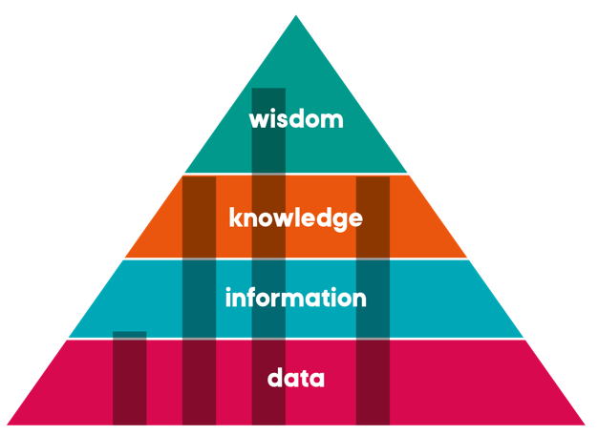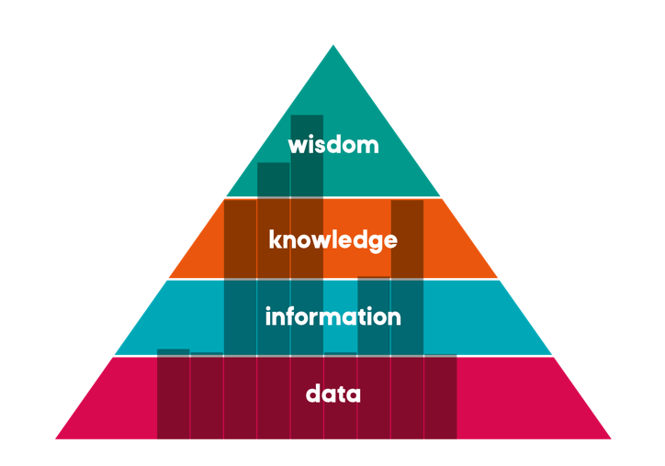
The benefit of the vertical strike approach is that it can quickly demonstrate ‘the art of the possible’ to the business. This approach reduces the risk to the whole process of building the DIKW pyramid. It also provides an opportunity to be an evangelist for new ways of working, and/or technologies. As each vertical strike is contained, it should not take a long time to deliver, and can provide valuable business insight which can be quickly operationalised.

The plan of these strikes must be clearly communicated with the organisation’s leadership team, to ensure they understand what is going on, the scaling implications (if that is the outcome), and that their expectations are managed.

For the rest of the organisation, this strike approach also draws together the ‘data people’, as they become interested in understanding what is going on and they want to be involved. It is important to build a narrative around these tactical vertical strikes. Build a narrative to tell a story that is recognisable across the organisation and uses a common language, so that the whole organisation is buying into the same plan and outcomes.
These first vertical strikes do provide the opportunity for the CDO’s team to create and propagate the common language of ‘data’ that will be used in the organisation. An example is if the vertical strike is a data Extraction, Transformation and Load (ETL) exercise. This exercise will do away with inefficient legacy work around processes involving spreadsheets, and the whole business will soon start using terms such as ‘ETL’; understanding that this is a data process and how it fits into other projects and business processes.
Remember to always focus on the strategic vision, and never lose sight of the vision that is the completed pyramid. It can be very easy to be drawn into the ‘here and now’, the tactical, and lose focus on the strategic.

Relating to the rest of the C Suite

Relationship building is a key skill for a data leader. Working with data means that you are cutting across the silos in the organisation, and therefore potentially messing around in everyone else’s garden… So you had better ask nicely before you do or have some cover for when an area department feels pain for the greater good of the business. While you must form a good solid working relationship with all the stakeholders, the one that must be defined and agreed (as it is currently causing the most concern) is that of the relationship between the CDO and CIO.
Building a relationship is a bit like a dance, there needs to be give and take, but someone has to make the first move. If you are the one to lead the change, then the onus is on you to be that person.
Do not assume that just because someone is a whiz at finance, or an expert in HR, that they really ‘get’ data. Be prepared to gently enlighten your colleagues and share your understanding and enthusiasm for what data can do for them.

Scott Taylor – The Data Whisperer

Telling Your Data Story With the 3Vs: Vocabulary, Voice and Vision
Data Leaders must create a compelling narrative to evangelize their Data Management programs and secure long-term support from enterprise stakeholders and business leadership. Data management leaders who seek to improve soft skills and execute simple storytelling techniques will be more likely to gain a rightful place for their initiatives on their organization's strategic plan.
- Why you need a Data Management narrative vs other Data Storytelling and Data Literacy Efforts
- Why Data Management is Macro-Trend agnostic
- Leveraging the 3Vs: Vocabulary, Voice and Vision

Useful Links
Too Much Tech Talk? (A puppet service announcement)
The Little Red Data Hen - A Cautionary Tale
Connecting Data Management to the Essence of Your Business
Data Has Got to Move to Have Value
The Super Hero Adventures of **Master Data**

Extra credit for watching more!
Scott Taylor - The Data Whisperer YouTube Channel
Website: www.metametaconsulting.com

Get the Book

Telling Your Data Story- Data Storytelling for Data Management
The Data Whisperer’s practical guide to explaining and understanding the strategic value of data management. The need for data management is everywhere across your company. The value of every digitally transformative customer-facing initiative, every data science and analytics-based project, every as-a-service offering, every foray into e-commerce, and every enterprise software implementation is inextricably linked to the successful output of data management efforts. Although it is a simple function of garbage in garbage out, that slogan rarely drives any sustainable executive action. We need to tell a better data story.
Data Storytelling is probably the hottest non-technical trend in the technology-related space. But it does not directly support data management because it is focused on analytics or telling stories with data. So, it is time to expand the realm of Data Storytelling to recognize the role of data management by telling stories about data.
SUMMER SCHOOL STUDENT DISCOUNT: 20% off with code: DATAWHISPERER
https://technicspub.com/data-storytelling/
Also available on Amazon.

Please Follow Scott Taylor on LinkedIn
https://www.linkedin.com/in/scottmztaylor

Scott Taylor’s Bio
Scott Taylor, The Data Whisperer, has helped countless companies by enlightening business executives to the strategic value of proper data management. He focuses on business alignment and the “strategic WHY” rather than system implementation and the “technical HOW.” As Principal Consultant for MetaMeta Consulting he helps Enterprises and Tech Brands tell their data story.
An avid business evangelist and original thinker, he continually shares his passion for the strategic value of master data through industry events, public speaking opportunities, blogs, videos, whitepapers, podcasts, cartoons, puppets shows and all forms of thought leadership. His new book – TELLING YOUR DATA STORY: Data Storytelling for Data Management is available now.
He lives in Bridgeport, CT where he often kayaks in Black Rock harbor. He can also juggle pins and blow a square bubble.

Homework

List the reasons why your organisation needs to have a data leader; what are those driving factors that make it real for you?

Find an example of data in your organisation moving through the DKIW pyramid.

What is the wisdom that will arise from the DKIW? Try and be as aspirational as possible.

Program Content

This is the content for the 10-week program:

Week 1- June 29th
Understanding the different types of CDO and what kind you are

Week 2 – July 6th
Making the Case for the CDO & business case development. Telling Your Data Story With the 3Vs:
Vocabulary, Voice and Vision

Week 3 – July 13th
Planning for your First 100 Days and Beyond & The C&J Data Maturity Assessment overview.

Week 4 – July 20st
Strategy development: Purpose

Week 5 – July 27th
Strategy development: Risk and Governance

Week 6 – August 3rd
The role of People

Week 7 – August 10th
Methodology

Week 8 – August 17th
Tools

Week 9 – August 24th
Building your team & Authentic Leadership

Week 10 – August 31st
The Chief Data Officer as a disrupter & wrap up of the Summer School 2023

The Summer School Community

As a participant of Summer School, you have joined a community of current and aspiring CDOs, where you will gain practical advice, proven methodologies and guidance to put back into the business straight away. Your homework as you progress through the course will build a series of artifacts for you to use in your organisations.
Exclusive Community Groups

Within the Carruthers and Jackson website, there is an area just for you. The ‘Exclusive Content’ section is solely for the participants of the Summer School.
The group will be used to share pre-class work, classroom materials, and homework. You will also be able to catch up on all sessions missed.

We have also created a Slack group and a LinkedIn Group. These groups will provide an environment to network and interact with peers. Please check the groups regularly for updates and information or drop in to say hi to your fellow students.

You can access the Community Page & Groups here:

Website:
https://carruthersandjackson.com/exclusive-summer-school-content/

Slack:
https://join.slack.com/t/carruthersjac-w3l8573/shared_invite/zt-1wdo67jdg-KuR8qZdxQOe1hLYabFPGRw

LinkedIn:
https://www.linkedin.com/groups/12845246/

These groups are reserved for the sole use of the Summer School, the school leaders, and participants. Please ensure you remain respectful to other group members, at all times. Any posts that are commercial or deemed unsuitable by the group managers will be removed.

